# CellProfiler Workshop Practice 3: 3D monolayer

### We will use the images in the folder: **CPW3_Example_3DSegmentation**

### This tutorial features of human induced pluripotent stem cells from the Allen Institute of Cell Science: <https://bbbc.broadinstitute.org/BBBC034>

CellProfiler 3D currently only works with TIFF files. The acceptable CellProfiler format for storing z-stacks is to have a separate TIFF file for each channel.

Appropriately naming the output(s) of each CellProfiler module is important in order to avoid confusion, especially in large and complex pipelines. Throughout this tutorial we will suggest names for each of the outputs, but feel free to use your own.

## Importing data in CellProfiler

1. Click on the Images module.
2. Drag-and-drop the **CPW3_Example_3DSegmentation** folder you will analyse into the Images module window.
3. Click on the Metadata module.
4. Enter the following regular expression:

**^(?P<Plate>.*)_xy(?P<Site>[0-9])_ch(?P<ChannelNumber>[0-9])**

This regular expression will parse the filenames and organize the data. Click Update to check.

1. Click on the NamesAndTypes module.
2. Assign a name to “Images matching rules”.
3. Choose “Process as 3D”
4. Populate the fields for “Relative Pixel Spacing”.

For this example, the relative pixel spacing is **0.26 in x and y and 0.29 pixels in z**.

The actual units do not matter, rather their relative proportion. The numbers are unitless.

1. Create “rule criteria” to identify an image by its colour/channel. For example, using the Metadata you just extracted -Metadata -> Does -> Have ChannelNumber matching -> 0 would match the first image.
2. Give the images “variable names” that describe the contents of the image. For example, use the name *dna* to describe an image stained with DAPI.
3. Add images with rulesets for the other channels in the experiment. In this case, Channel 0 contains images of the plasma membrane, Channel 1 contains images of mitochondria, and Channel 2 contain images of DNA. You can name them *origMemb*, *origMito* and *origDNA*, respectively.

# Find objects: nuclei

## Image preparation

Before attempting to segment the cells in the images, pre-processing the images with filters and various image processing methods will improve the results.

1. Add a **RescaleIntensity** module for the DNA channel. Rescaling the DNA image proportionally stretches the intensity values to the full intensity range, from 0 to 1. In this case, we find that rescaling improves the thresholding and subsequent segmentation of nuclei. When using rescaling in your pipelines, be careful to perform measurements on the original images, not the rescaled images. Name the output *RescaledDNA*.

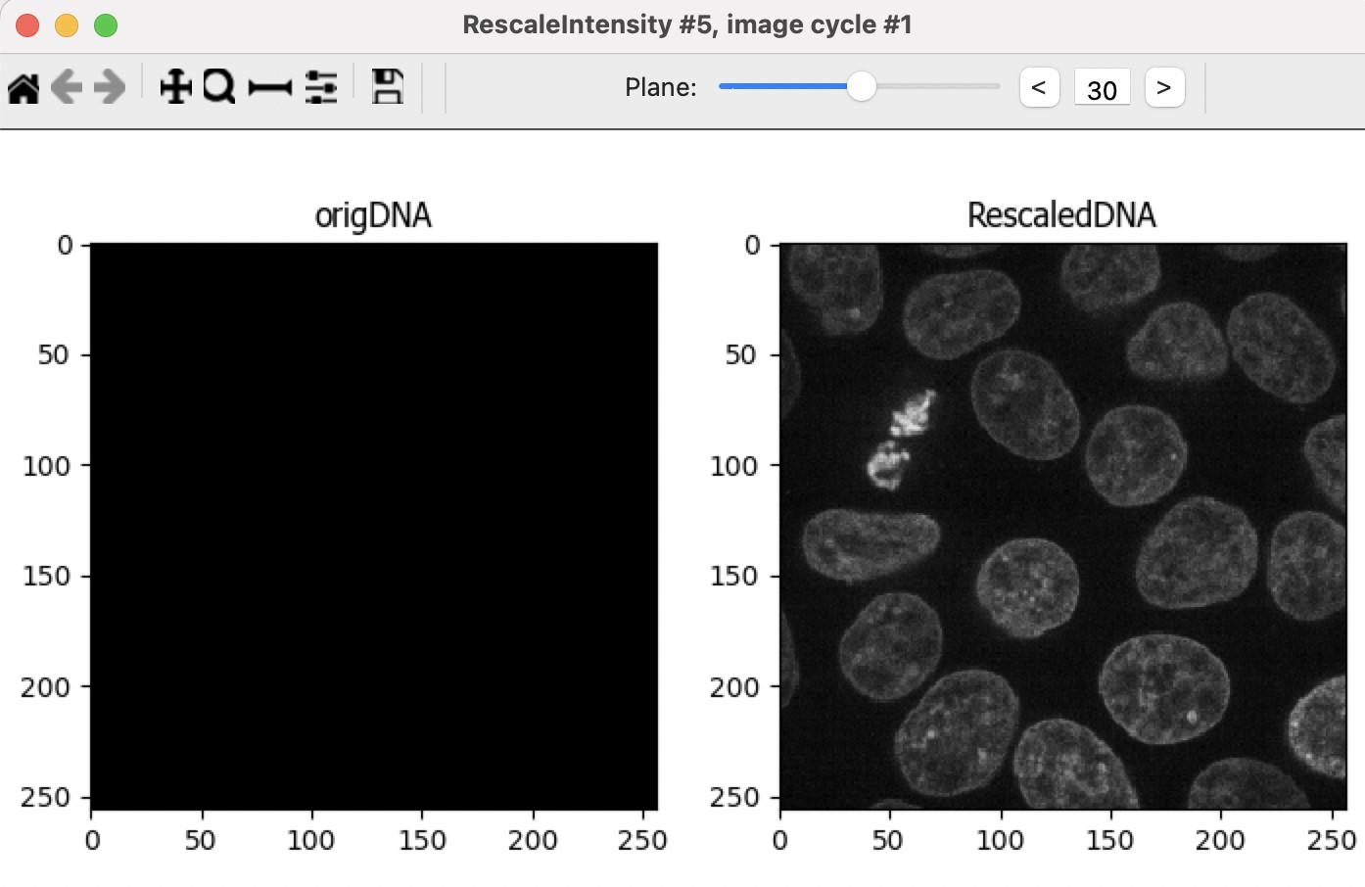

1. Add a **Resize** module on your rescaled image. Processing 3D images requires much more computation time than 2D images. Often, downsampling an image can yield large performance gains and at the same time smooth an image to remove noise. Final segmentation results will be minimally affected by downsampling if the objects of interest are relatively large compared to the pixel size. Choose a value of *0.5* for both *X* and *Y*, this will halve each of the XY dimensions, so the resulting image will have a quarter of the area of the original. *Do not resize Z* (keep the factor at *1*), otherwise you will discard images from the Z stack. Name the output *ResizedDNA*.

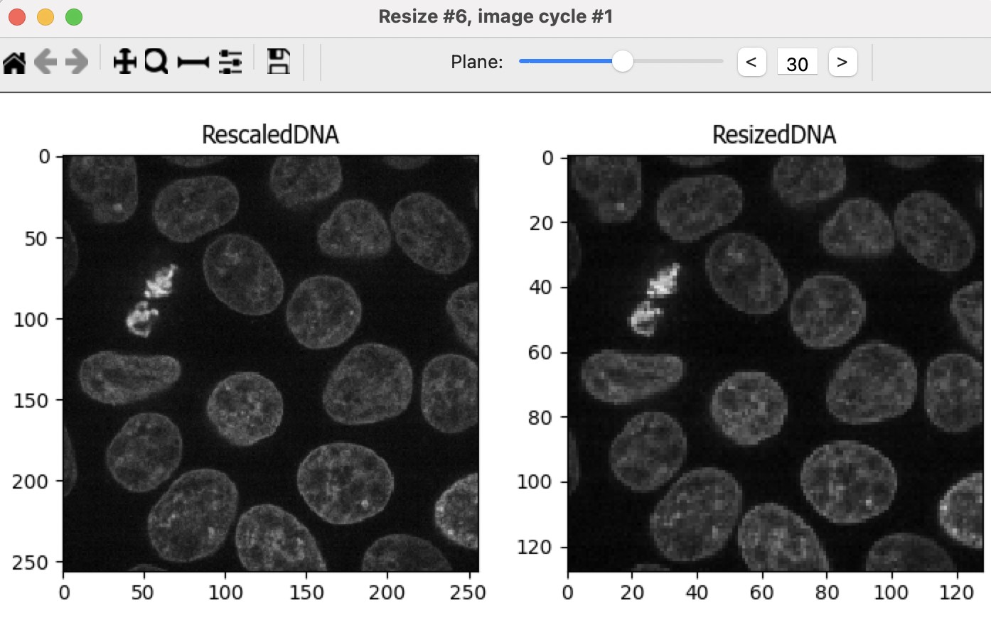

1. Add a **MedianFilter** module. A median filter will homogenize the signal within the nucleus and reduce noise in the background. DNA is not uniformly distributed throughout the nucleus, which can lead to holes forming in the downstream object identification. A median filter will preserve boundaries better than other smoothing filters such as the Gaussian filter. For the example images, choose a filter size of *5*. This number was chosen empirically: it is smaller than the diameter of a typical nucleus; it is small enough that nuclei aren’t merged together, yet large enough to suppress over-segmentation of the nuclei. Name the output *MedianFiltDNA*.

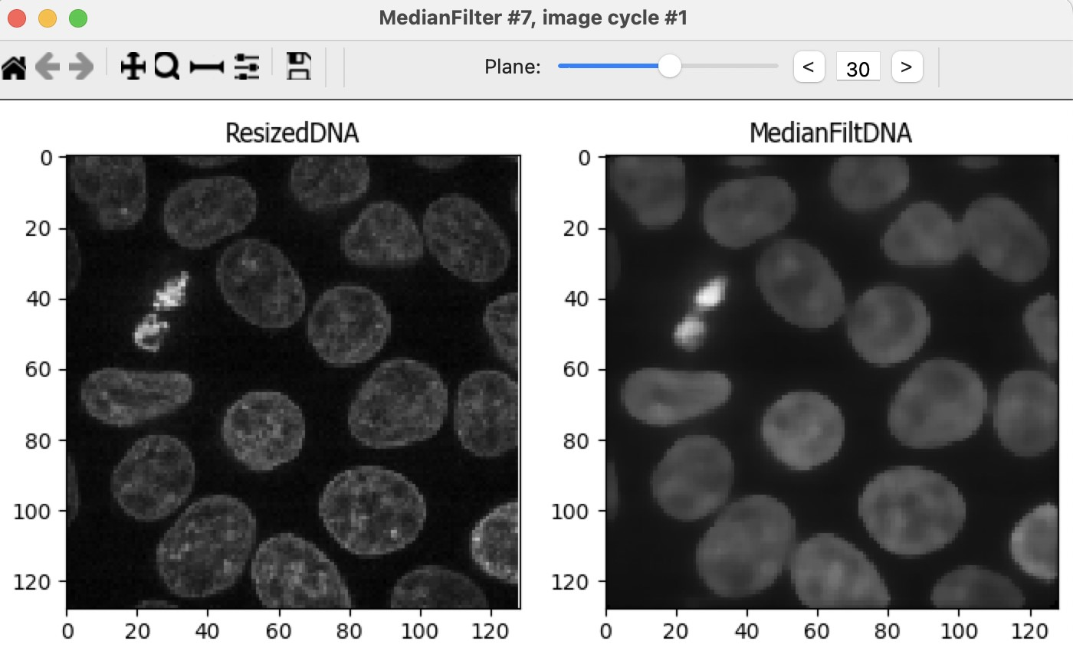

## Segmentation

In CellProfiler 4 (and previous versions) the *IdentifyPrimaryObjects* module does not support 3D images. Thus, we will have to use a different strategy to segment the nuclei.

1. Add a **Threshold** module. This identifies a pixel intensity value to separate the foreground (nuclei) from the background. Empirically, we’ve found that a two-class Otsu threshold works well for this data. We encourage you to try other thresholding methods to compare the outputs. Name the output *MaskDNA*.

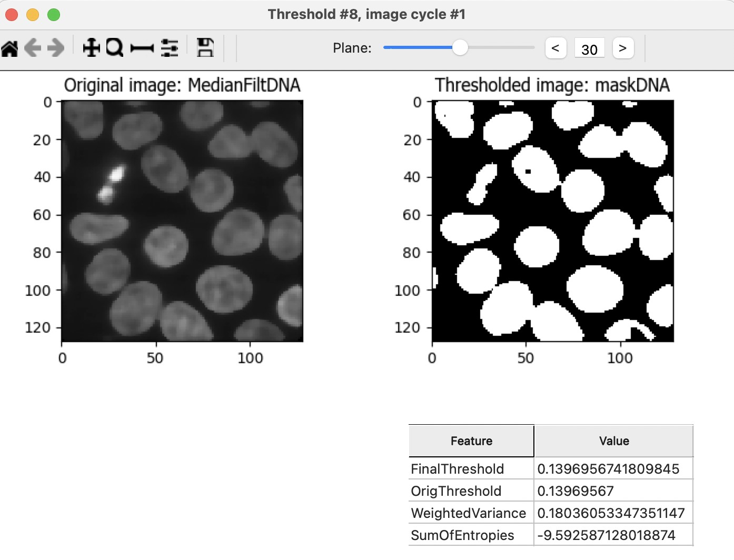

1. Add a **RemoveHoles** module. This module implements an algorithm that will remove small holes within the nucleus. Any remaining holes will contribute to over-segmentation of the nuclei. Choose a size of *20*.

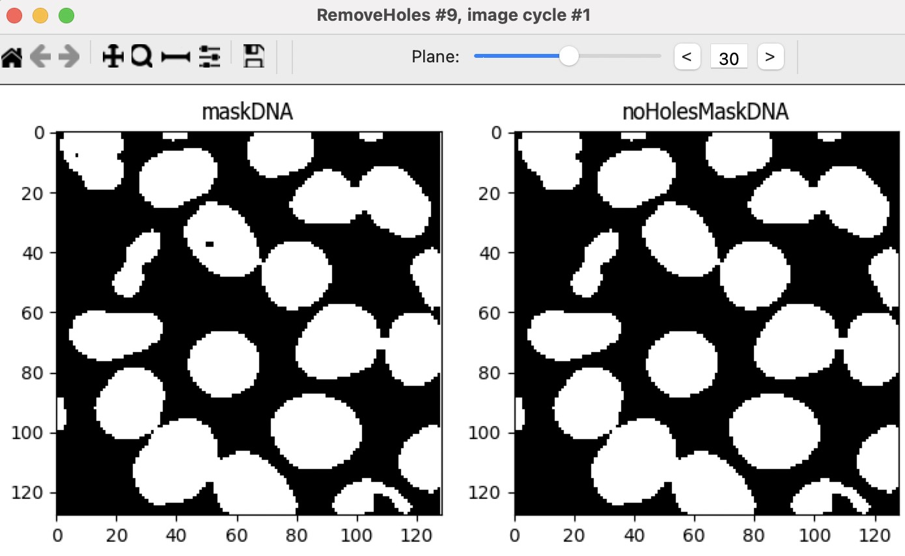

1. Add a **Watershed** module. This module implements the watershed algorithm, which will segment the nuclei. Select a Footprint of *10* and Downsample by *2*. Downsampling reduces processing time and decreases noise. For more information on the watershed algorithm refer to this helpful [MATLAB blog post.](https://www.mathworks.com/company/newsletters/articles/the-watershed-transform-strategies-for-image-segmentation.html)

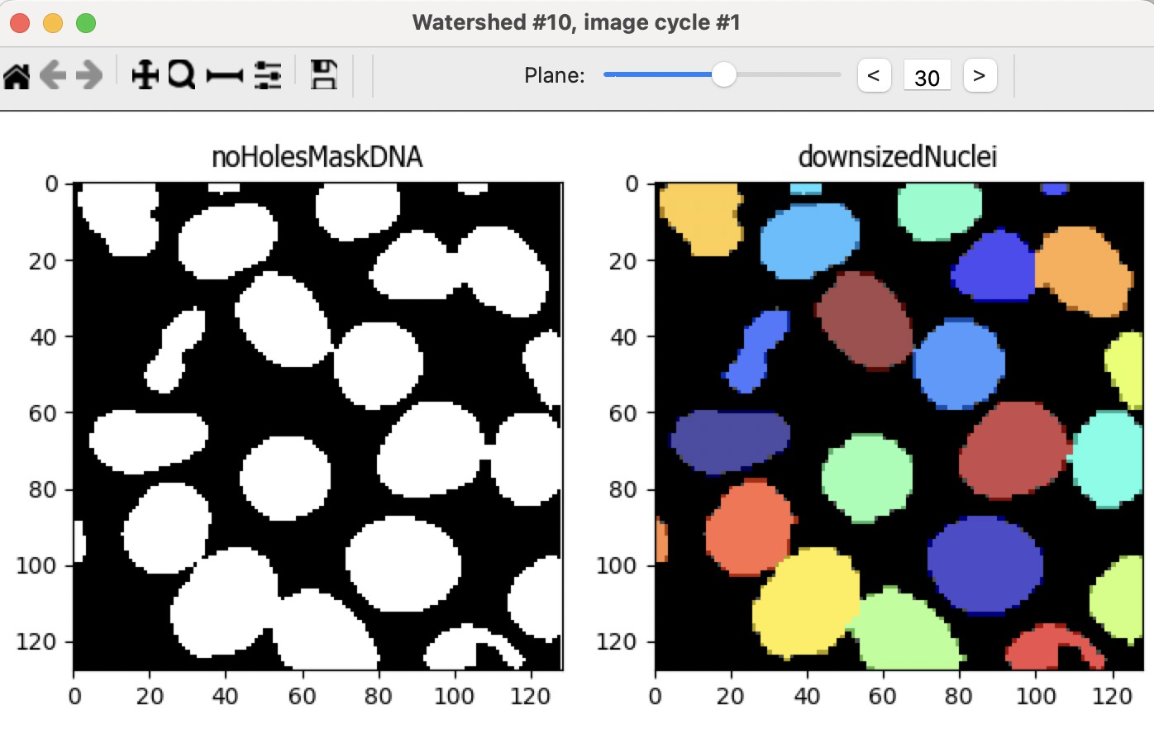

1. Add a **ResizeObjects** module to return the segmented nuclei to the size of the original image. Since the original image was scaled down by *0.5*, it must be scaled up by *2* in x and y. The output of this module is the nuclei we are seeking. Name the output *Nuclei*.

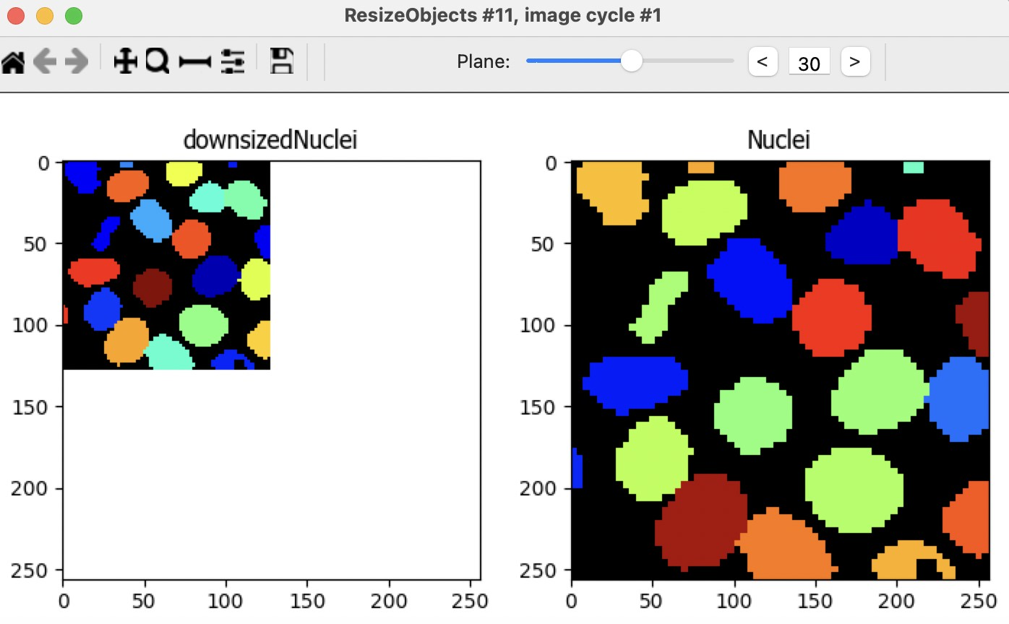

# Find objects: cells

Now that we’ve segmented the nuclei, we want to segment the cytoplasm for each nuclei whose boundaries are defined by the membrane channel. The membrane channel presents more of a challenge because, unlike the nuclei, the membrane signal is variable and the boundaries are connected together in a sort of mesh. However, we can use the location of the nuclei we already found as 'seeds' to guide the Watershed module later on to identify regions with cells.

## Transform nuclei into seeds

1. We will start by shrinking the nuclei to make them more seed-like by adding an **ErodeObjects** module. Use the *ball* structuring element with a size of *5*. Select “Yes” for the “Prevent object removal” option in order to avoid losing any nuclei.

We’ve found that we can achieve the best results by applying **ErodeObjects** to the output of the Watershed module rather than the resized Nuclei that are at the original size (since the Watershed output has been downsampled, the resulting seeds from **ErodeObjects** are smaller and more seed-like). So, select the *downsizedNuclei* object as input. Name the output *erodedDownsizedNuclei*.

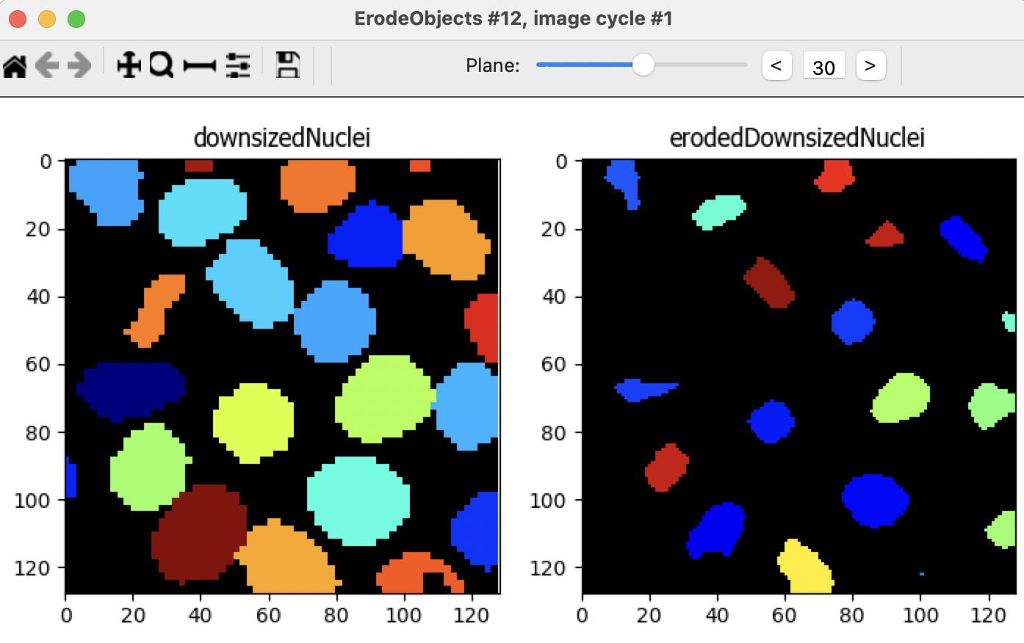

1. Resize these seeds using the **ResizeObjects** module with a factor of *2*. Name the output *erodedResizedNuclei*.

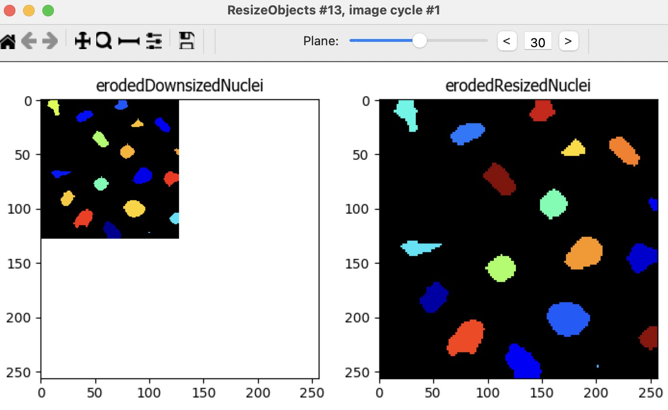

1. Next convert the eroded and resized nuclei to an image using the **ConvertObjectsToImage** module. Select the *uint16* color format. This image will serve as the seeds for segmenting the cells. Name the output *cellSeeds*.

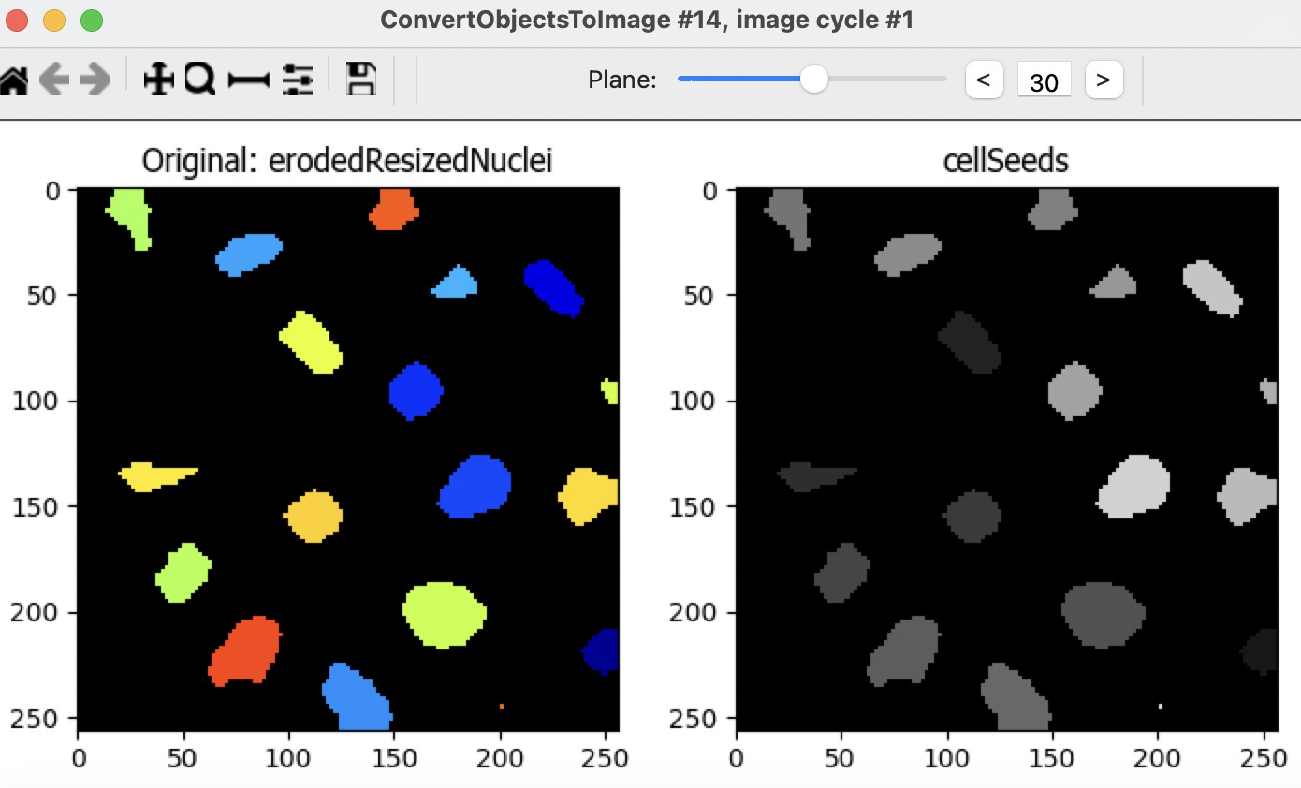

## Transform the membrane channel into cytoplasm signal

The Watershed module finds objects that have bright signal, so the cytoplasm that will define the cell volume should have bright signal. However, this is not the case in the membrane channel; it must be transformed into an image where the cytoplasm is bright and the boundaries between the cells are dark. Therefore, we will invert the membrane channel to achieve this effect.

1. Add a **Threshold** module and threshold the original membrane image (*origMemb*). We find that the *Otsu three-class* method with middle intensity pixels assigned to the foreground works well, but feel free to try others. Name the output *MembThreshold*.

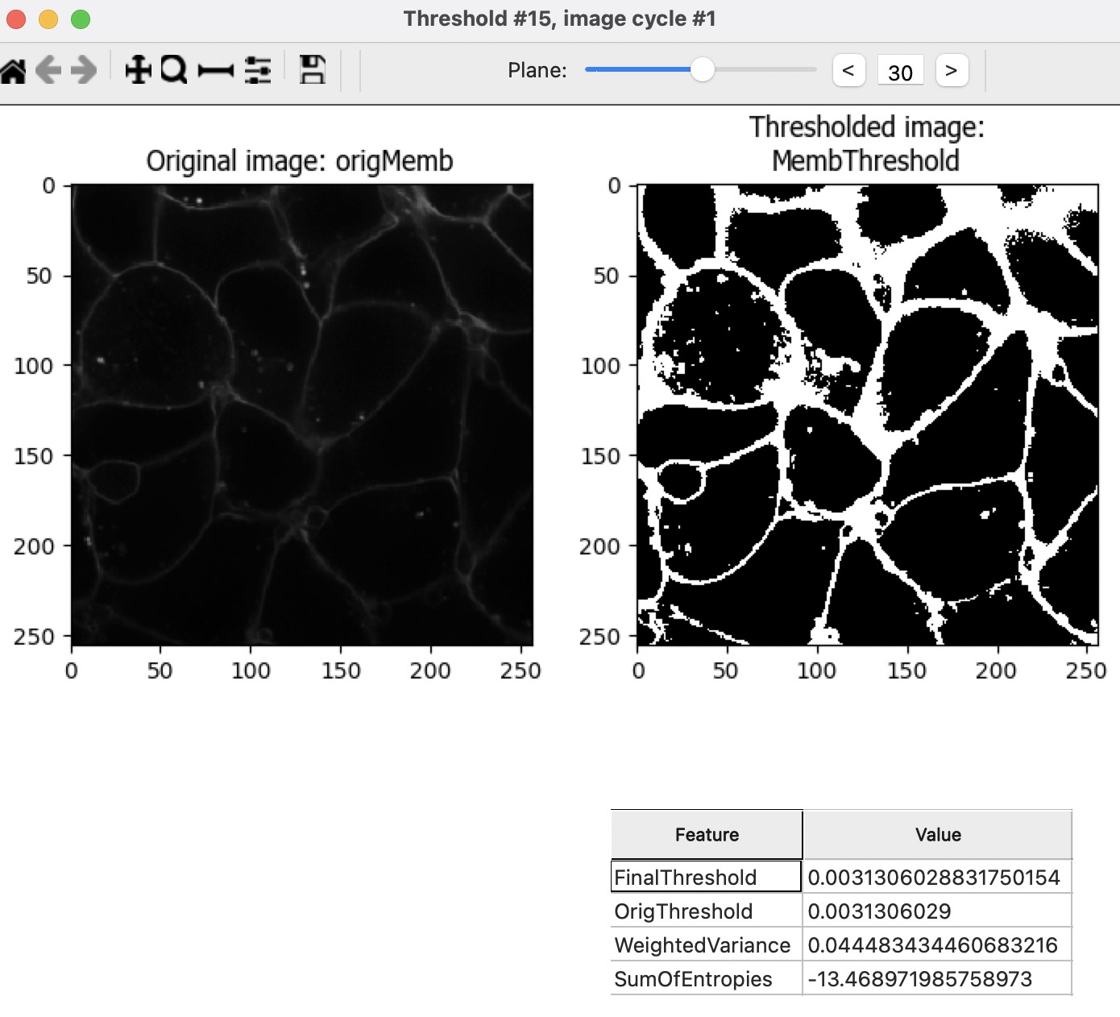

1. Add an **ImageMath** module. Within the ImageMath module choose the *Invert* operation, and invert the thresholded membrane. Name the output *MembInvert*.

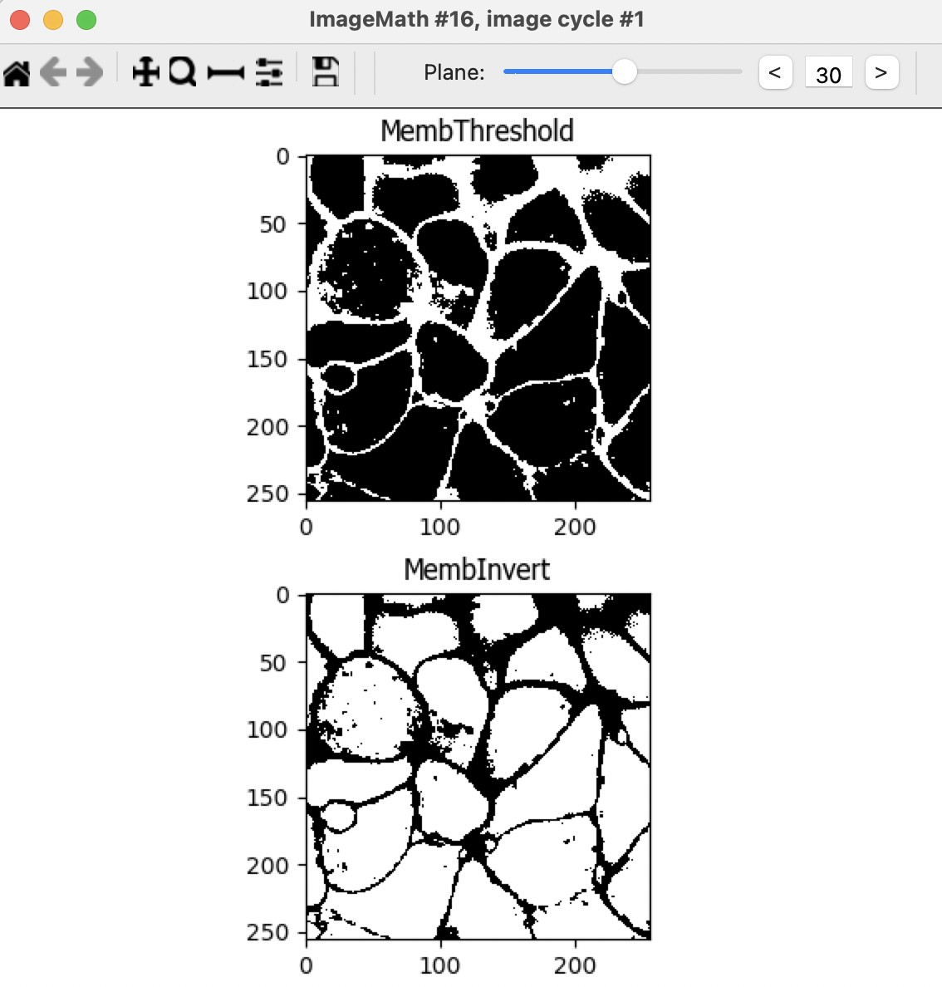

1. Add a **RemoveHoles** module to remove the small holes in the segmentation of the cell interior. This helps to prevent the cells from being split during the Watershed segmentation. Choose a size of *20*. Name the output *MembInvertRemoveHoles*.

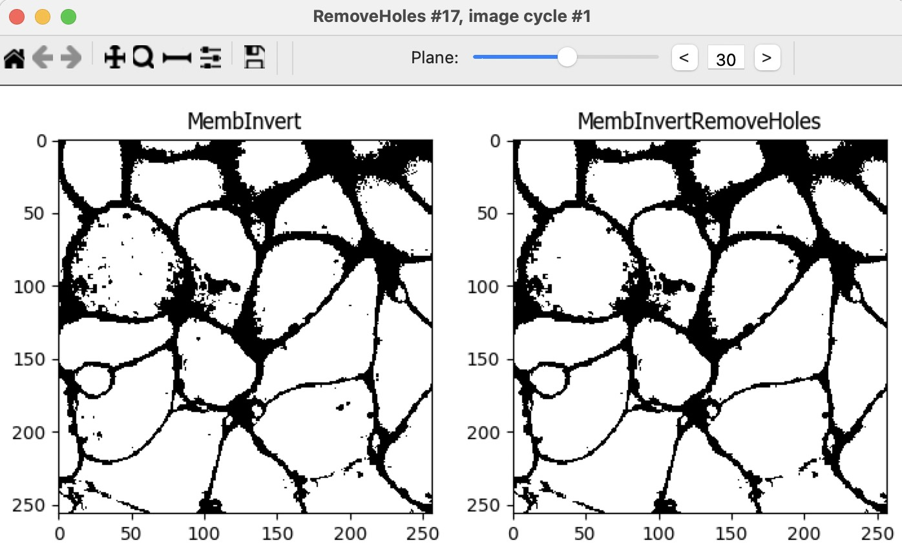

1. Add another **ImageMath** module. Add all of the original images together. This creates a composite image that will be used in the following steps to define where cells are present and the background above and below the cells. Name the output *Monolayer*.

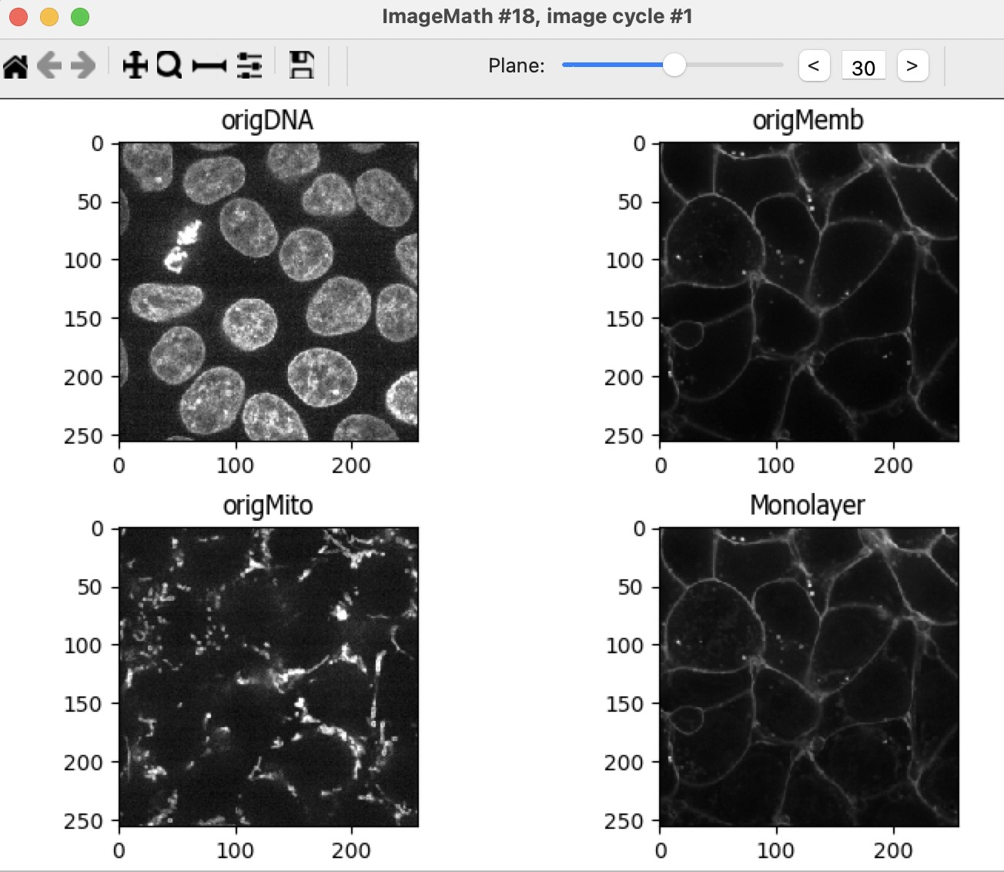

1. Add a **Resize** module to resize the Monolayer with a *Resizing factor* of *0.25* for X and Y (keep a factor of

1.0 for Z). Downsampling the image makes processing faster and decreases noise. Name the output *DownsizedMonolayer*.

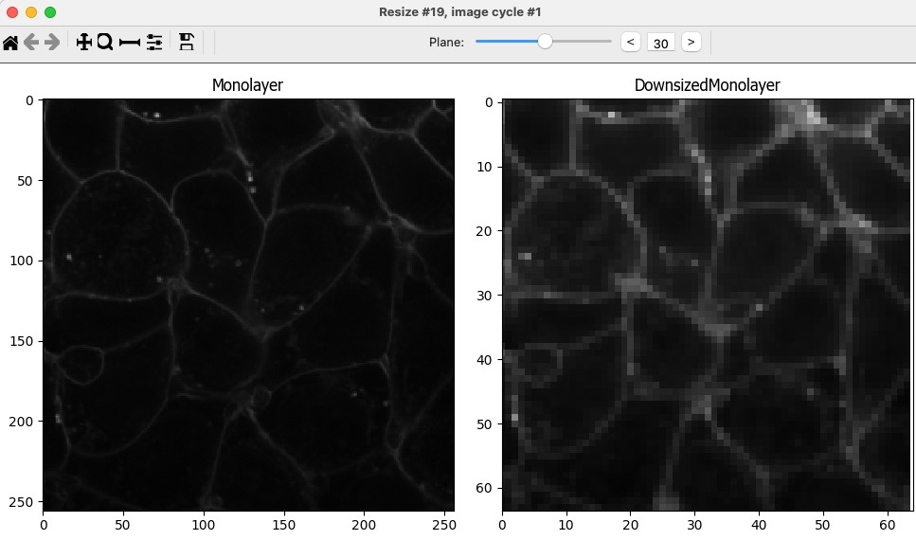

1. Add a **Closing** module. Choose a size of *17* to blend the signal together. The result should look like a cloud of signal where the monolayer resides. Name the output *ClosedDownsizedMonolayer*.

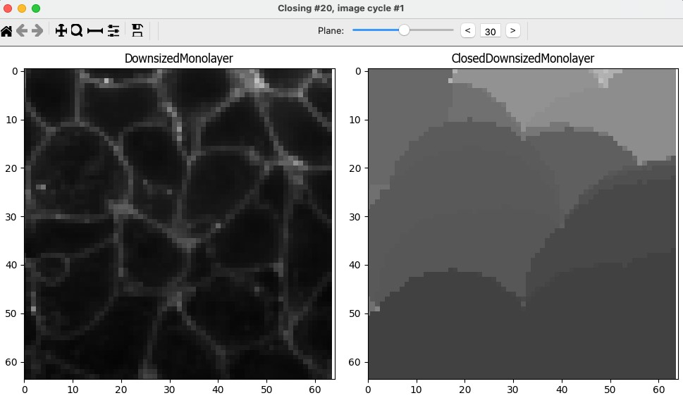

1. Add a **Resize** module to resize the closed Monolayer back to its original size, *Resizing factor* of *4* for X and Y (keep a factor of *1.0* for Z). Name the output *ResizedClosedMonolayer*.

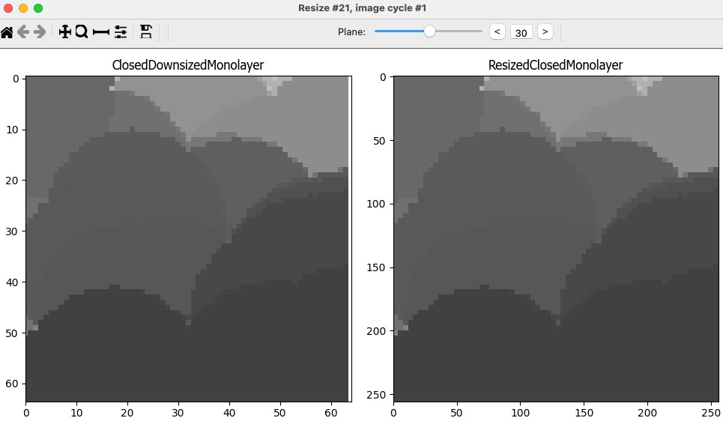

1. Add a **Threshold** module and threshold the smoothed monolayer image. The idea is to end up with a 3D mask of the region where the cells of the monolayer exist in. We found that using a global Otsu method with three classes (middle class identified as foreground) works well for this example. This will define what is and is not monolayer. Name the output *MonolayerMask*.

Note that most of the middle planes of the stack should be completely white (part of the monolayer), while the regions above and below are primarily black (not part of the monolayer).

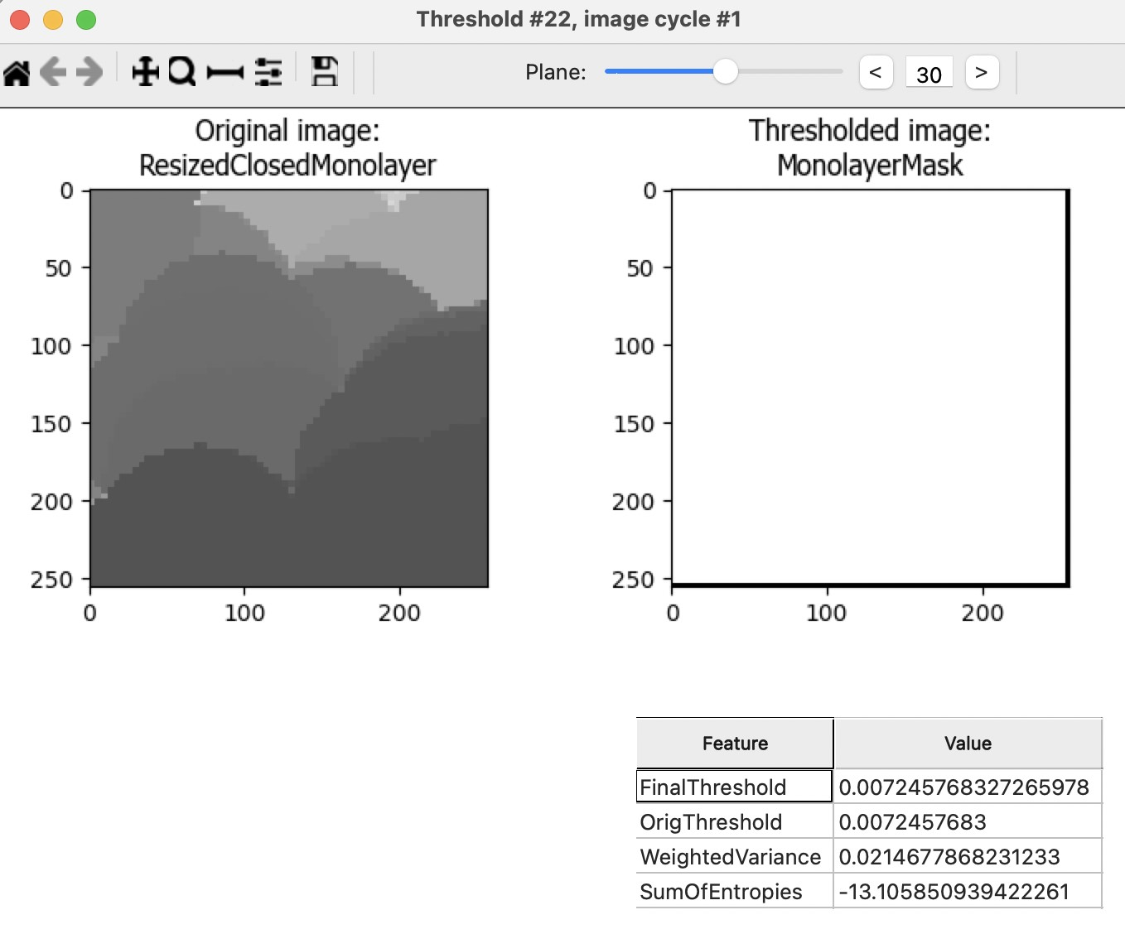

1. Add a **MaskImage** module. The input image is *MembInvertRemoveHoles*.

You will use an *Image* as a mask (the MonolayerMask image generated in the previous step). In this case, the mask does not need to be inverted. Note that the planes on the bottom and top of the z-stack are black in the masked image. Name the output *MembMasked*.

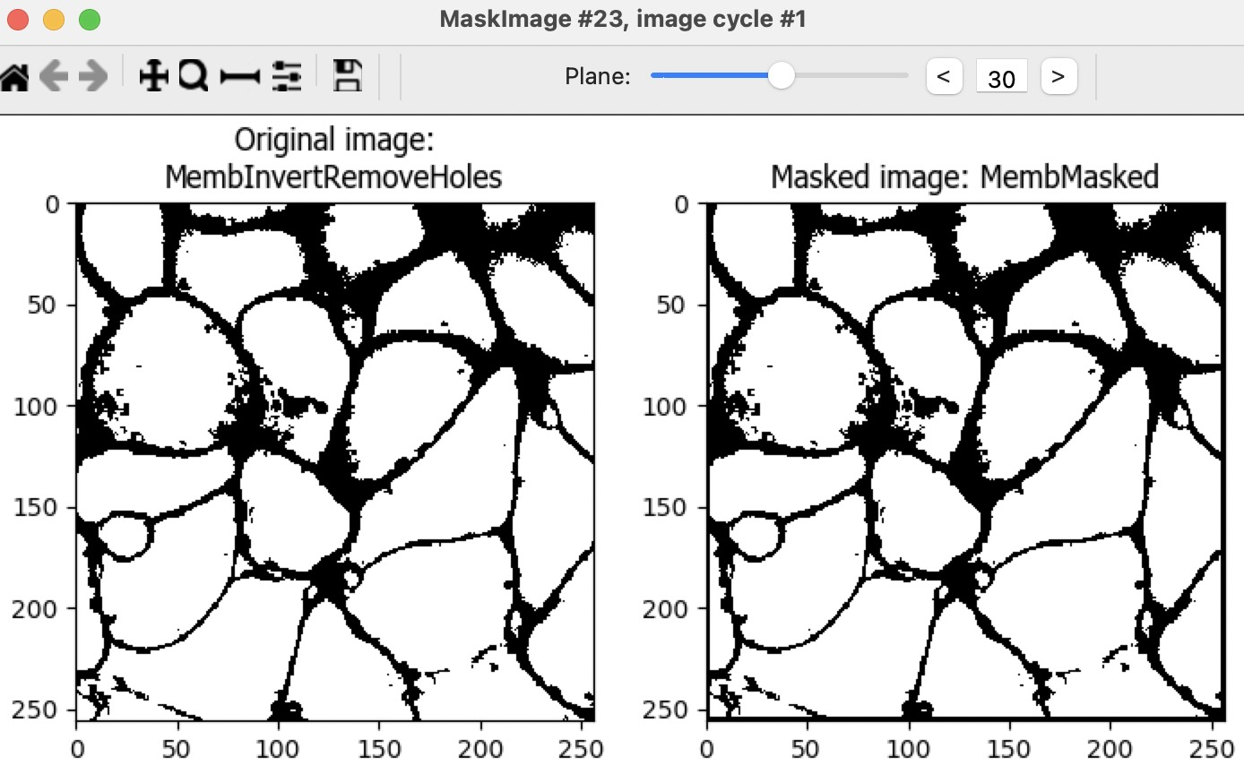

1. Add an **ErodeImage** module. We will use this module to erode the membrane image generated in the previous step. Eroding using a *ball* of size *1* improves the separation between individual cells in the Watershed segmentation (the next step). Name the output *MembFinal*.

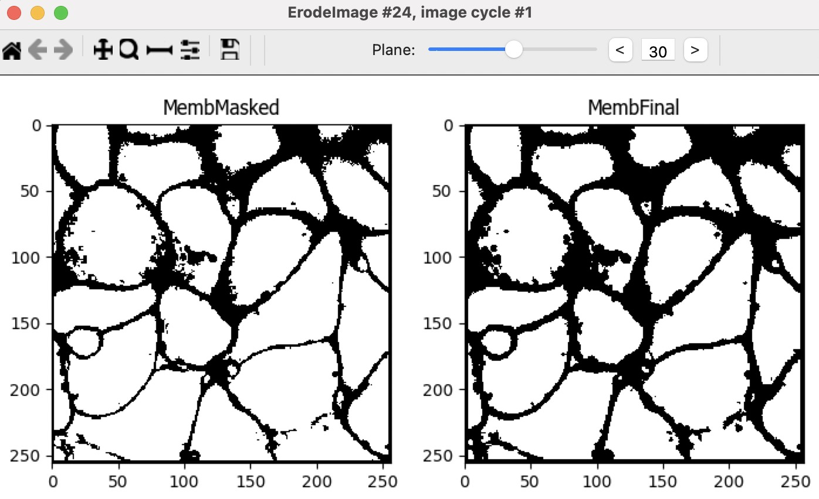

1. Add a **Watershed** module. The input is the result of the previous ErodeImage module, referred to here as the MembFinal. Change the *Generate from* option to *Markers*. The Markers will be the *cellSeeds* image,

which is the output of the ConvertObjectsToImage module. Finally, set the Mask to also be the *MembFinal*. This will help preserve the cell boundaries. Name the output of this module *Cells*.

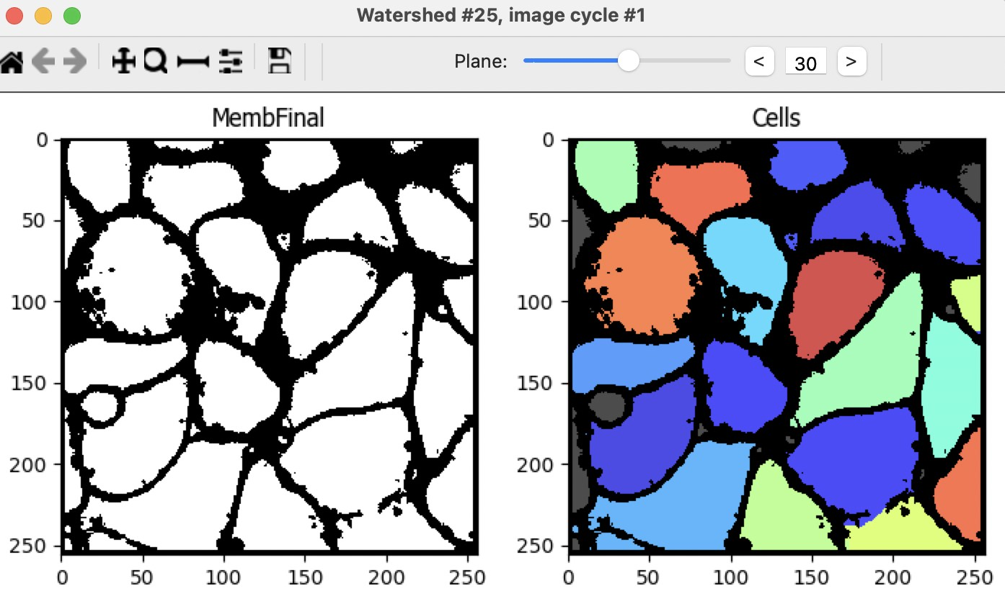

# Making measurements

Now that the nuclei and cells have been segmented in this monolayer, measurements can be made using modules from the **Measurements** category.

1. Add any desired measurements modules. For example, you might choose to **MeasureObjectIntensity** and/or **MeasureObjectSizeShape**. When applying these measurements, be careful to measure the original images, not rescaled images.

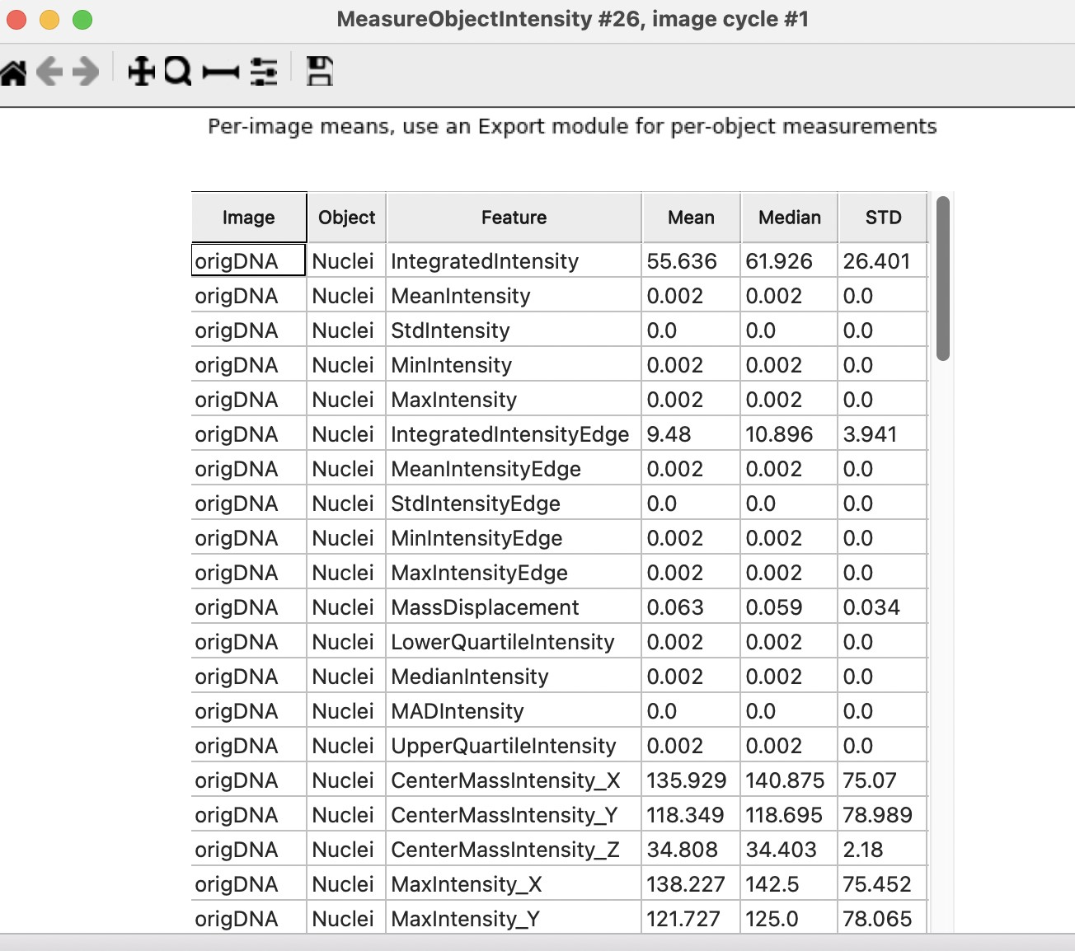

# Creating visuals

Congratulations! The nuclei and cells have been segmented and measured in this monolayer. Visuals that reveal the details of the segmentation can be also be created within CellProfiler. The following steps will walk you through two different options to visualize your CellProfiler segmentations.

1. You can convert the objects to images using the **ConvertObjectsToImage** module and then save the output using **SaveImages**. This option will allow you to visualize the segmentations directly in Fiji and use them as masks for further processing.

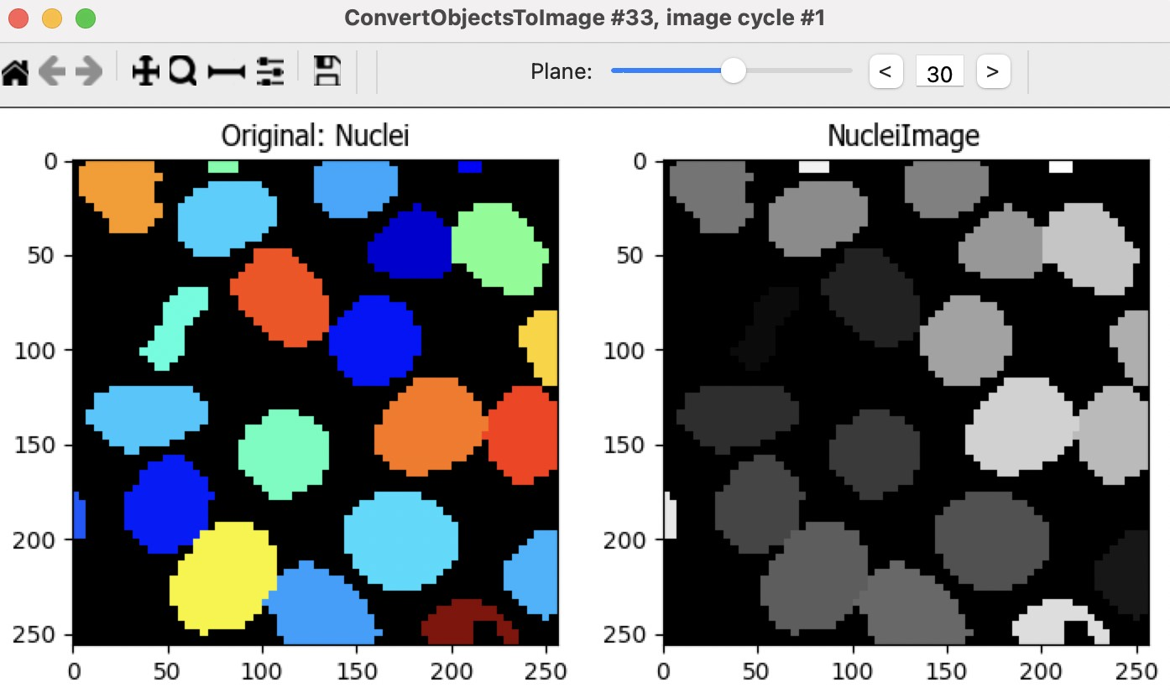

# Export measurements

1. Save the output of the measurements modules using **ExportToSpreadsheet**.

It’s good practice to place all export modules at the end of your pipeline. CellProfiler automatically calculates execution times for each module that was run before the export module. By placing your export modules at the end of your pipeline, you will have access to module execution times for each module in your pipeline.

Thank you for completing the 3d monolayer tutorial!